MGMS – Search Project

Functional Specification Document

Ver. 1.4

Version History
Version # | Date | Description
1.0 | 08-Nov-2010 | First Draft
1.1 | 03-Dec-2010 | Added sections “Advance Search”, “Grant Search”
1.2 | 10-Dec-2010 | Added Status message

Table of Contents

Version History 2
1 Introduction 4
1.1 Purpose 4
1.2 Scope 4
1.3 Assumptions 4
1.4 Constraints 4
2 Sub menu – Search Projects 4
3 Business Rules 7
4 Status Messages 7

Introduction

Purpose

This document provides the requirements and functional specifications for the project Search functionality in the Multisite Grant Management System project.
This is not a project plan or a design document. It is a guide for system architecture and development, not for phasing, timelines or deliverables.
Finally, this is a ‘living document’ and the specification will change, continuously, as the project proceeds. More details will be added and the existing information edited as the requirements, scenarios and use cases evolve in the course of the project.

Scope

Assumptions

Constraints

Sub menu – Search Projects

Clicking on Search Projects on the left navigation bar opens the page as shown below.

Screen & Control Description

Figure 1: Project – Simple search
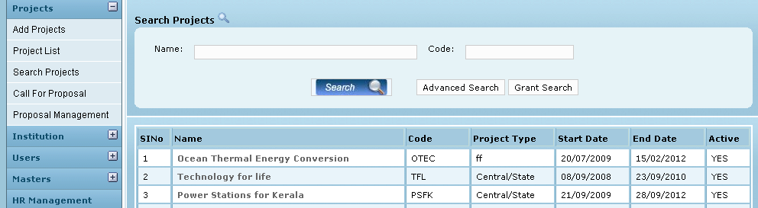

Clicking on Search in the screen (without entering any name or code) will display all the projects currently run by the user’s institution.
For specified inputs of project name and/or code, the system will display results satisfying the given search criteria.

Partial strings are also recognized. For e.g. when search criteria is Code = “OT” the results should contain an entry corresponding to the project whose code is “OTEC”.

Field /Label | Input-Control | Data Type | Details
Search Projects
Name: | Textbox | String
Code: | Textbox | String
Search | Button |  | On clicking, the table below is populated with criteria satisfying projects.
Advanced Search | Button |  | On clicking, the advanced search screen opens up as shown in Fig 2
Grant Search | Button |  | On clicking, the Grant search screen opens up as shown in Fig 3
SlNo | Auto increment populated
Name | Auto populated | String
Code | Auto populated | String
Project Type | Auto populated | String
Start Date | Auto populated | Date
End Date | Auto populated | Date
Active | Auto populated | char(1)

Clicking on Advanced Search will open the page as shown below:

Figure 2: Project – Advanced search
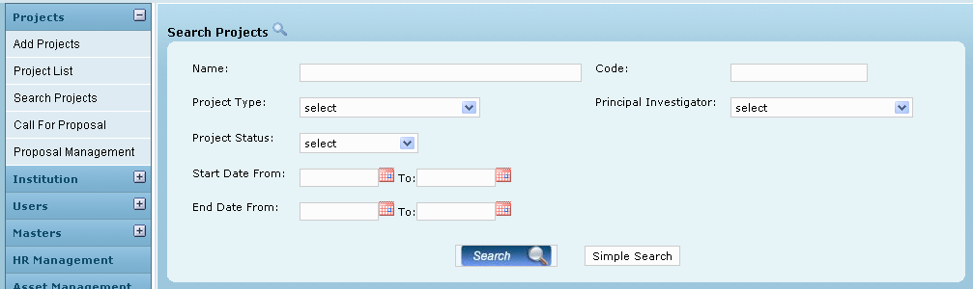

As can be seen, more search criteria can be given to narrow down the search. Clicking on Simple Search reverts back to the main search page

Field /Label | Input-Control | Data Type | Details
Search Projects
Name: | Textbox | String
Code: | Textbox | String
Project Type: | Listbox
Principal Investigator: | Listbox | String
Search | Button |  | On clicking, the table below is populated with criteria satisfying projects.
Simple Search |  |  | On clicking, the Simple search screen opens up as shown in Fig 1
SlNo | Auto increment populated
Name | Auto populated | String
Code | Auto populated | String
Project Type | Auto populated | String
Start Date | Auto populated | Date
End Date | Auto populated | Date
Active | Auto populated | char(1)

Clicking on “Grant Search, as the name implies, opens the page as shown below:

Figure 3: Grant Search
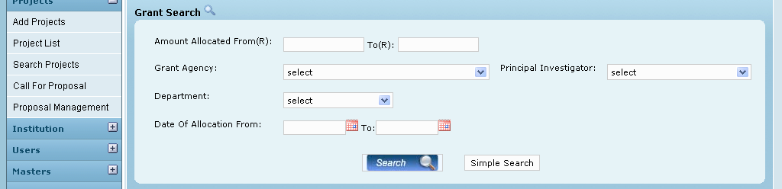

Field /Label | Input-Control | Data Type | Details
Search Projects
Name: | Textbox | String
Code: | Textbox | String
Project Type: | Listbox
Principal Investigator: | Listbox | String
Search | Button |  | On clicking, the table below is populated with criteria satisfying projects.
SlNo | Auto increment populated
Name | Auto populated | String
Code | Auto populated | String
Project Type | Auto populated | String
Start Date | Auto populated | Date
End Date | Auto populated | Date
Active | Auto populated | char(1)

Clicking on Simple Search reverts back to the main search page

Business Rules

Partial strings should be allowed as search criteria
No distinction between uppercase and lower case

Status Messages

Sl No | Status Message
1 | The Requested File Not Found
2 | No results found

